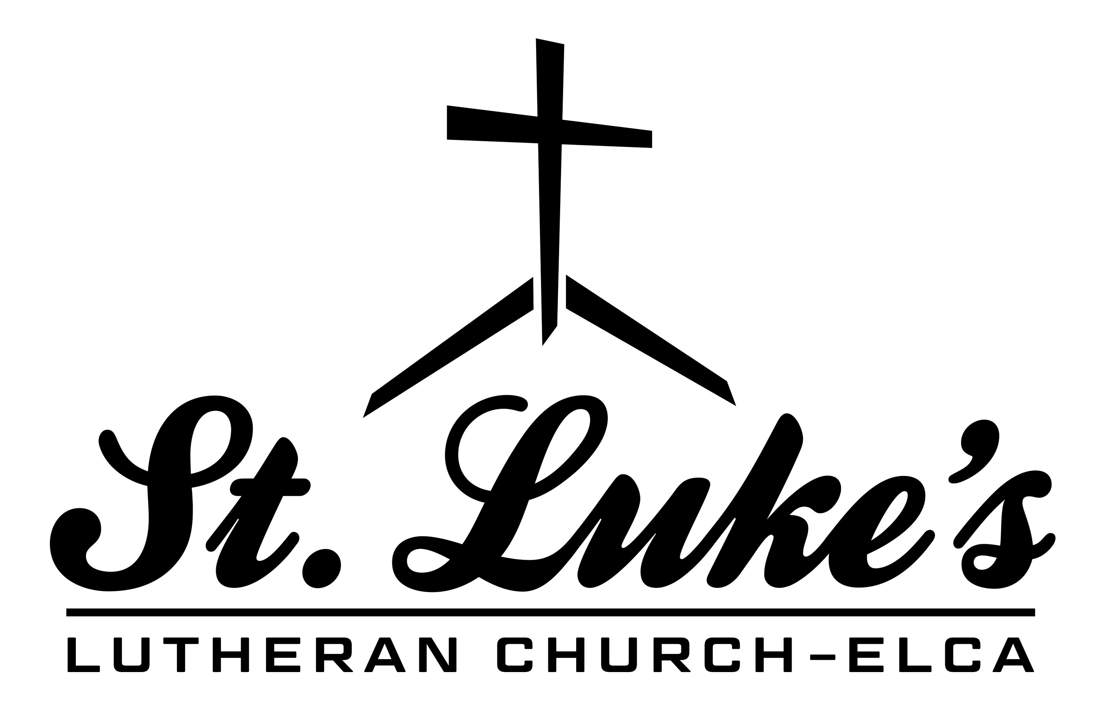

Children and Youth Ministry Coordinator

Effective Date: August 1, 2022
Position: Children’s and Youth Ministry Coordinator
Reports To: Children’s, Youth and Family Director
FLSA Status; Job status: Full-time (40 hours/week), Non-Exempt

God’s purpose for St. Luke’s Lutheran Church is to connect, serve and grow in Christ’s love. Our guiding principles are Jesus is Lord, All are Saved by Grace, All are Welcome and Accepted, Worship is Vibrant and Accessible, Share God’s Gifts Boldly, Service is Love in Action, Listen and Learn Openly, Dream Courageously, and Question Faithfully. The Full-Time Children’s and Youth Ministry Coordinator focuses this purpose and core values on children and teens as they prepare to become adults in the faith and the church community.

Job Duties
- Inspire others through a commitment to Christ and a life of service in God’s word.
- Provide vision and leadership for the Children’s Ministry program. This includes, but is not necessarily limited to:
  - Direction and oversight Sunday School programs during the school year.
  - Direction and oversight the annual Vacation Bible School.
  - Organizing the Christmas Program.
  - Evaluation of new curriculum as needed.
- Work alongside the Children’s, Youth and Family Director in developing and overseeing ministry for grades 6-12. This includes but is not necessarily limited to:
  - Planning retreats.
  - Assisting with Confirmation Program.
  - Organizing and leading summer experiences.
  - Planning and leading Middle School Youth Group.
  - Planning and leading High School Youth Group.
  - Planning annual mission trip.

- Maintain program growth through promotion, inviting, and personal conversations.
- Meet with and counsel youth and youth volunteers.
- Recruit, equip, train, oversee, and inspire Children’s and Youth Ministry volunteers and hold them accountable.
- Ensure background checks are performed and educate all adults on protocol when working with children and youth.
- Coordinate with the Children, Youth & Family (CYF) ministries at all times, to include working with the CYF team and attending meetings with the team.
- Receive continuing education or attend conferences as decided in conversation with CYF Director.

Knowledge, Skills, and Abilities
- Good inter-personal and relationship building skills with children, youth and adults.
- Ability to assist with and lead a strong Children’s and Youth Ministry with enthusiasm, creativity, and energy.
- Ability to plan, organize, and implement activities and programs with minimal supervision. Strong organizational skills are a must (self-starter, detail-oriented, multi-tasking, and can delegate).
- Ability to lead the congregation in faith-based, spiritually uplifting worship services and to effectively relate to children and their families through education, counseling and outreach.
- Ability to speak well, persuasively, and inspirationally in public settings.
- Ability to think creatively, to dream new approaches as necessary to Children’s and Youth Ministry.
- Liberal understanding of the Christian faith that embraces and communicates a theology that is accepting, exciting, and open to frank discussions with children and youth about their doubts, hopes and faith.
- Must possess a valid driver’s license and a good driving record.
- Must have good computer skills and an ability to work within social media and the ability to use Microsoft Word, create PowerPoint presentations, manage an Excel worksheet.

Education/Experience
- Lutheran theological grounding.
- Prior experience in children and/or youth leadership is preferred.
- Bachelor’s degree preferred.

Communication
- Strong written communication skills, both internally and with respect to the public.
- Persuasive and engaging communication style.
- Ability to interact effectively with professional staff and volunteers.
- Ability to communicate effectively with young children and youth.

- Strong interpersonal skills including the ability to work as part of a team.
- Understanding the importance of Confidentiality.

Decision Making/Problem Solving
- Ability to solve problems quickly and efficiently, independently or in collaboration with others, while keeping the CYF Director and Program staff advised.

Physical Demands
This position requires the ability to do one or more of the following throughout the day: stand, walk, run, sit, bend, and reach above and below shoulder level. This position also requires the ability to drive, sometimes long distances.

